**Images of Pixels Plotted (Low Res Version)**

Below, plotted images in order of increasing wavelength. The **purple dots** plotted show successful, perfect fits. The **red dot** is the original pixel I tested where I could not make a perfect fit. NOTE I CAN fit pixels *next to* (1 pixel to right / left) of that red dot.

Hα:

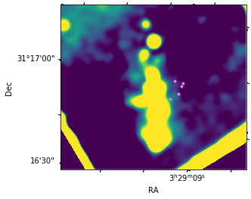

1.26:

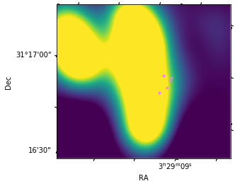

1.28:

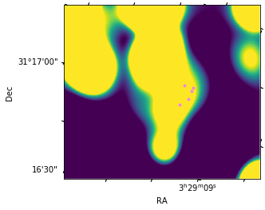

1.64:

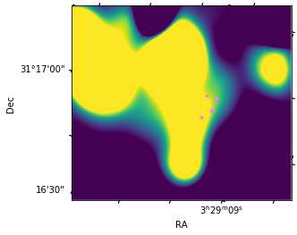

**Blackbody Fits**

Fitting the blackbody fits

Repeat labeling the regions by number only for reference on relative position:

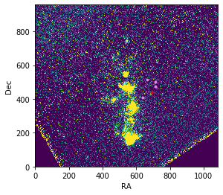

1

2

3

4

5

Table of fit properties:

|  |  |  |
| --- | --- | --- |
| Region # | T (K) | C |
| 1 | 2.69276711e+03 | 2.08456832e-23 |
| 2 | 2.24833984e+03 | 3.34560847e-23 |
| 3 (translated by ~10 pixels) | 6.75899674e+03 | 1.24505865e-24 |
| 4 | 2.94369669e+03 | 1.35597189e-23 |
| 4 (1 pix right, up) | 2.87200831e+03 | 1.47657956e-23 |
| 4 (1 pix left, up) | 2.95519163e+03 | 1.34915941e-23 |
| 5 | 3.72003286e+03 | 9.19077176e-24 |

Blackbody plots (same order as table):

1…

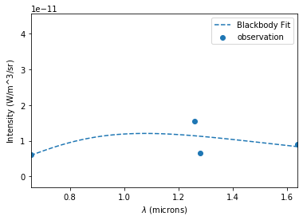

2…

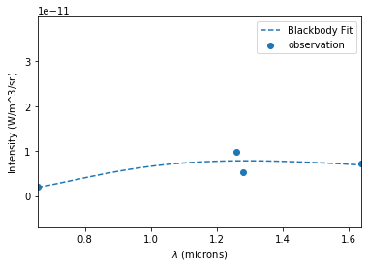

3 (translated by ~10 pixels)…

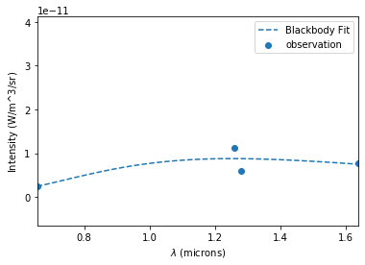

4…

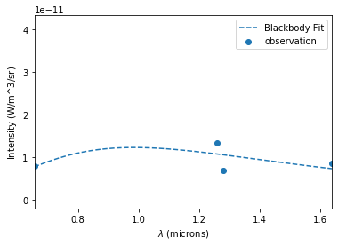

4, 1 pix up, right…

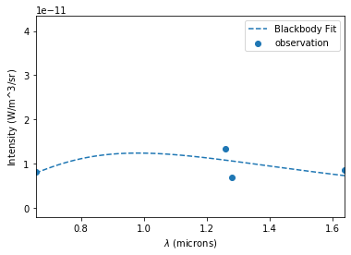

4, 1 pix left, up…

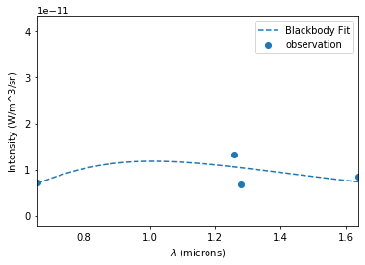

5…

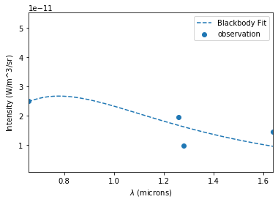

**Fitting Non-Lin Equs for Multiple Pixels**

For each pixel, I *fit by scipy curve_fit*. Newton-krylov will converge to a similar but slightly more accurate value from my tests on the one pixel that didn’t fit, but it is slower to do that, so I’m doing this for efficiency. I consider a fit with the sum of squares is ~1E-40 to 1E-50 (and I can’t distinguish the points on the plot):

|  |  |  |  |  |  |
| --- | --- | --- | --- | --- | --- |
| Fit Parameter | C | AV | fH | fFe | Σ(squares) |
| 1 | -2.45977472e-22 | 8.35379303 | 1.84369177e-10 | 1.34018699e-10 | 4.698219216958938e-53 |
| 2 | -2.07689865e-22 | 8.96471430 | 9.86578776e-11 | 7.42284712e-11 | 5.383376186098783e-54 |
| 3 (translated by ~10 pixels) | -2.35471551e-24 | 2.82156371 | 2.88044647e-11 | 2.35900626e-11 | 3.817303113779137e-52 |
| 4 | -1.28619614e-22 | 7.67381288 | 1.46538320e-10 | 9.86143311e-11 | 5.22024357439882e-54 |
| 4 (1 pix right, up) | -1.36093123e-22 | 7.78094390 | 1.43399847e-10 | 9.73817504e-11 | 3.6541705020791737e-53 |
| 4 (1 pix left, up) | -1.27406439e-22 | 7.64724499 | 1.47216483e-10 | 9.90226620e-11 | 2.871133965919351e-53 |
| 5 | -3.35046118e-23 | 5.57218751 | 9.89995454e-11 | 7.14174382e-11 | 1.044048714879764e-52 |

Intensity Plots of Fits (same order):

1…

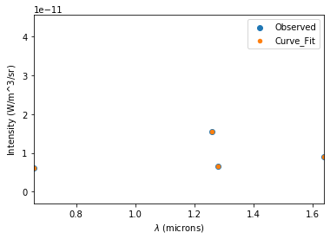

2…

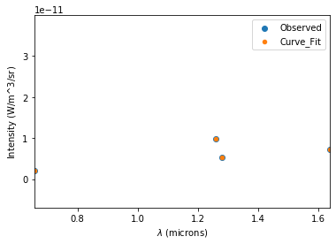

3 (translated by ~10 pixels)…

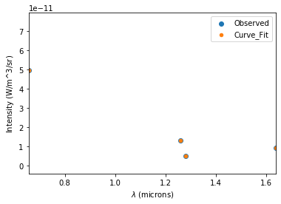

4…

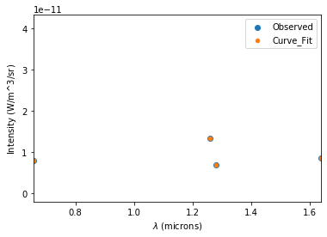

4, 1 pix right, up…

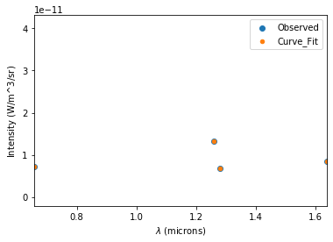

4, 1 pix left, up…

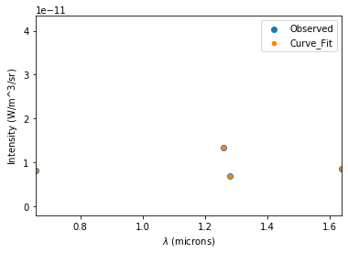

5…

